2020-2021 DANCE SHOE ORDER FORM

Dancer’s Name______________________________ Phone #___________________________

PLEASE CHECK OFF SHOES YOU ARE ORDERING:
TAP SHOES
___Caramel Buckle Tap Shoes $27.00 plus tax + $1.79 = $28.79 SIZE _____ (Pre-Sch. & Kinder/1st)
___Caramel Pull-On Tap Shoes $32.00 plus tax + $2.12 = $34.12 SIZE _____ (2nd thru 5th Grade)
___Black Tie Tap Oxfords $55.00 plus tax + $3.64 = $58.64 SIZE _____ (6th Grade and Up)

BALLET SHOES
___Pink Ballet Shoes $20.00 plus tax + $1.33 = $21.33 SIZE _____ (Pre-School & Kinder/1st)
___Nude Half Sole Shoes $25.00 plus tax + $1.66 = $26.66 SIZE _____ (2nd Grade and Up)
___Pointe Shoes $65.00 plus tax + $4.31 = $69.31 SIZE _____ (Advanced Dancers)
___Deluxe Gel Toe Pads For Pointe Shoes $25.00 plus tax + $1.66 = $26.66
___Sewing Fee For Pointe Shoes (Ribbons/Elastic) = $5.00
___Turning Socks $23.00 plus tax + $1.52 = $24.52 SIZE _____ (4th Grade and Up)

ACRO SHOES
___Black Acro Shoes $22.00 plus tax + $1.46 = $23.46 SIZE _____ (Pre-School & Kinder/1st)

JAZZ/TUMBLE SHOES
___Tan Bloch Jazz/Tumble Shoe $47.00 plus tax + $3.11 = $50.11 SIZE _____ (2nd Grade and Up)

HIP HOP SNEAKERS
___Sequin Hip Hop Sneakers $32.00 plus tax + $2.12 = $34.12 SIZE _____ (Small Fry thru 5th Gr.)
___Gold Hip Hop Sneakers $56.00 plus tax + $3.71 = $59.71 SIZE _____ (6th thru 8th Grade)
___White Hip Hop Sneakers $56.00 plus tax + $3.71 = $59.71 SIZE _____ (High School)
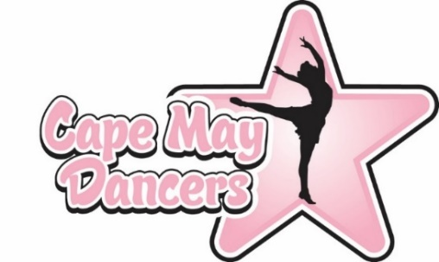
ORDER TOTAL $_______________________
DATE __/__/__
CASH______ CHECK #_______ C/C___

